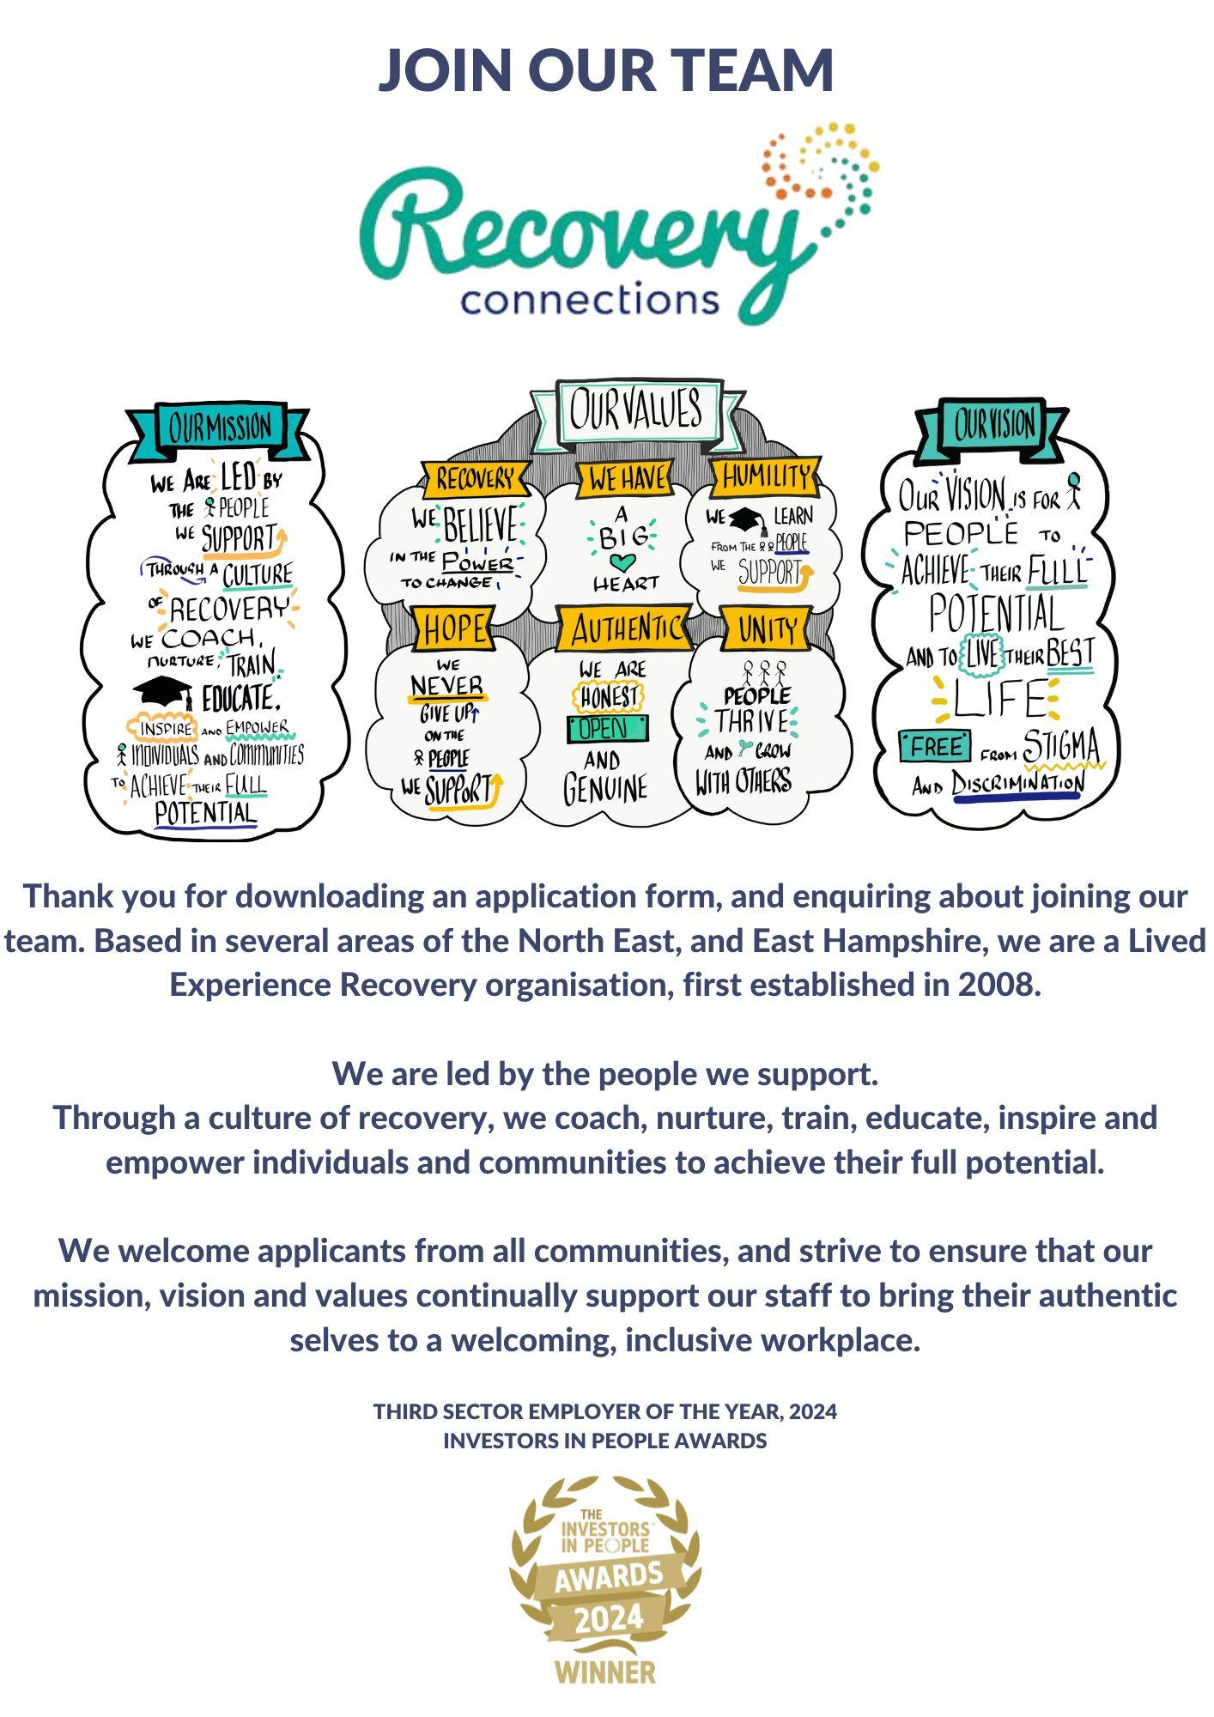
Position Applied for:
Applicant Ref No:
Please do not send your CV as this will be disregarded

Application for Employment

Personal Information

Surname

Forename(s)

Preferred name

Preferred pronoun(s)
Permanent Address |  | Contact Details
 |  | Home
 |  | Mobile
 |  | Work ^{(if convenient)}
Postcode |  | E-Mail Address
NI Number |  | Do you require a work permit or a letter of permission to work in the UK? |  |  | No

Referees
Name and address of two referees (one of whom must be your current/most recent employer)
Name |  | Name
Address |  | Address
Postcode |  | Postcode
Tel No |  | Tel No
Email address |  | Email address
Relationship |  | Relationship

Equal Opportunities Monitoring
Post Applied for:

- We aim to be an Equal Opportunities Employer and we select staff solely on merit. In order to monitor the effectiveness of our Equal Opportunities Policy, we ask all applicants to provide the information below.
- The information will only be used for monitoring purposes and will be treated as confidential and will not be seen by the selection panel.
- Monitoring the profile of our work force and users is an important element in ensuring our practices are effective. It also enables us to use positive action within the terms of the Equality Act 2010.

Gender Identity
Male |  | Female |  | Transgender |  | Non-binary/non-conforming |  | Gender Fluid |  | Prefer not to say

- Please indicate which ethnic group you feel describes you most
White – British |  | Mixed – White and Black Caribbean
White – Irish |  | Mixed – White and Black African
White – Other |  | Mixed – White and Asian
Asian or Asian British – Indian |  | Black or Black British – Caribbean
Asian or Asian British – Pakistani |  | Black or Black British – African
Asian or Asian British – Bangladeshi |  | Black or Black British – other
Asian or Asian British – Other |  | Other Ethnic Group
Chinese |  | Prefer not to say

- Please indicate which religious affiliation you feel describes you most
Christian | Muslim | Hindu | Jewish | Sikh | Buddhist | Other | None | Prefer not to say

- Please indicate which sexual orientation you feel describes you most closely
Heterosexual | Gay | Lesbian | Bisexual | Pansexual | Other/Prefer not to say

Disability Monitoring
Recovery Connections is striving to be an equal opportunities employer and guarantees an interview to those people with disabilities who meet the essential criteria for the job.

So that we can meet this commitment, could you please confirm whether or not you have an impairment that affects your day-to-day activities.

The Equality Act 2010 defines disability as:
A physical or mental impairment, which has a substantial and long-term adverse effect on a person’s ability to carry out normal day to day activities.
Would you describe yourself as disabled?
Yes |  | No
Please state any considerations that may help you of you are invited for interview.

Employment History

Present Employment details, or most recent if unemployed
Job Title |  | Department
Start Date |  | Annual Salary
Notice period/Date Left |  | Reason for Leaving

Main Duties

Previous Employment
Please give details of your working experience, including work experience training schemes & voluntary work starting with the most recent and working backwards. Please account for any gaps in your work record since leaving school.
Date Employed Month/Year  from – to | Job Title and  Main Duties | Salary | Reason for Leaving

Education and Training
Please include details of all relevant educational and vocational qualifications and training completed
School/College/University | Subject | Qualifications

Professional Memberships - Please give details of any professional memberships you hold
Awarding Body |  | Grade

Supporting Statement
This is where you can tell us in your own words a little bit about yourself (please continue on separate sheets if necessary).
You should include in your statement:-
- Why you want to apply for this post.
- How your skills/experience match the job description and person specification.
- Any details of other interests/voluntary work relevant to the post.

Additional Information
Do you have regular access to a car? | Yes |  | No
Do you have a valid full driving licence? | Yes |  | No
Would you be willing to consider a Job Share? | Yes |  | No
How did you learn of this vacancy? (please be specific)

Data Protection Act 1998
The information supplied on this form may be held on computer, and/or held as manual data. All the information supplied by you is strictly confidential and will only be used for the purpose of recruitment and personnel administration. Please note that we have the right to reject an application without giving a reason.
If unsuccessful in your application, do you wish to be considered for other posts (Yes/No)

I certify that the information in this application is accurate and complete to the best of my knowledge. I understand that the company may decline my application without giving reason.
Signed: |  | Date:

Any respondent wishing to e-mail the completed document back to us will be asked to sign the declarations should they be invited for interview.

Recovery Connections, Bedford House, 112 Linthorpe Rd, Middlesbrough TS1 2JR
www.recoveryconnections.org.uk

Tel 01642 351976

In the interests of economy we are unable to acknowledge receipt of applications. If you do not hear from us within 2 weeks of the closing date your application has been unsuccessful.
Recovery Connections is a Registered Company, Number 6545431.

